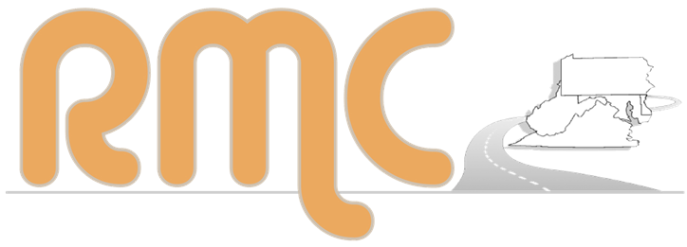
Roadway Management Conference
Ocean City, MD | October 27-29, 2025
At-a-Glance Agenda
Day 1: Monday, October 27
9:00 am – 5:15 pm | Registration | Terrace Lobby (2nd Floor)
9:30 am – 11:00 am | Pre-Conference Events: (For those who pre-registered.) | Meet at the Conference Center/ Hotel Entrance  (1st Floor)
9:30 am – 11:00 am | Event 1: The Ocean City Bike Experience | Meet at the Conference Center/ Hotel Entrance  (1st Floor)
9:30 am – 11:00 am | Event 2: An Accessibility Walkabout | Meet at the Conference Center/ Hotel Entrance  (1st Floor)
10:00 am – 5:15 pm | Vendor Area and Outdoor Displays Open (Parking Lot) | Atlantic Ballroom 2 (2nd Floor)
 | Lunch on Your Own
12:30 pm – 1:00 pm | Welcome, Opening Remarks, and Conference Tips | Atlantic Ballroom 1 (2nd Floor)
1:00 pm – 1:45 pm | General Session: Overview of Safety and Asset Management Programs | Atlantic Ballroom 1 (2nd Floor)
1:45 pm – 2:25 pm | Vendor Trivia | Atlantic Ballroom 2 (2nd Floor)
2:25 pm – 3:25 pm | Breakout Session 1
 | 1A: Pipe and Culvert Installation and Replacement | Seaside 1&2 (2nd Floor)
 | 1B: Public Works - Disaster Crisis Response | Seaside 5&6 (2nd Floor)
 | 1C: Working Across Generations: Enhancing Communication and Collaboration | Tideline B (1st Floor)
3:45 pm – 5:00 pm | Outdoor Demonstrations: Part 1 | Parking Lot
5:30 pm – 7:00 pm | Dinner (Cash Bar) | Tideline A (1st Floor)

Day 2: Tuesday, October 28
7:00 am – 8:00 am | Breakfast Buffet | Tideline A (1st Floor)
7:30 am – 5:00 pm | Registration | Terrace Lobby (2nd Floor)
7:30 am – 5:00 pm | Vendors & Outdoor Displays Open (Parking Lot) | Atlantic Ballroom 2 (2nd Floor)
8:00 am – 9:00 am | Breakout Session 2
 | 2A: Applications of Foamed Glass Aggregate for Roadway Work | Seaside 1&2 (2nd Floor)
 | 2B: Finance and Budgeting for Public Works | Seaside 5&6 (2nd Floor)
 | 2C: Winter Lessons Learned | Tideline B (1st Floor)
9:15 am – 10:15 am | Breakout Session 3
 | 3A: Pavement Preservation | Seaside 1&2 (2nd Floor)
 | 3B: Chainsaw Safety | Seaside 5&6 (2nd Floor)
 | 3C: Storm Water | Tideline B (1st Floor)
10:15 am – 10:45 am | Break with Our Vendors | Atlantic Ballroom 2 (2nd Floor)

Day 2, continued
10:45 am – 11:45 am | Breakout Session 4
 | 4A: Urban Landscaping | Seaside 1&2 (2nd Floor)
 | 4B: Public Works Outreach | Seaside 5&6 (2nd Floor)
 | 4C: The ABCs of Salt Brine | Tideline B (1st Floor)
11:45 am – 12:45 pm | Lunch | Tideline A (1st Floor)
12:55 pm – 1:55 pm | General Session: AI for Public Works | Atlantic Ballroom 1 (2nd Floor)
2:05 pm – 3:05 pm | Breakout Session 5
 | 5A: Confined Space Hazards | Seaside 1&2 (2nd Floor)
 | 5B: What Not to Say. What Not to Do. Guidance for Liability Neutral Language | Seaside 5&6 (2nd Floor)
 | 5C: Asset Management for Construction and Maintenance | Tideline B (1st Floor)
3:15 pm – 5:00 pm | Outdoor Demonstrations: Part 2 | Parking Lot
 | Dinner on Your Own

Day 3: Wednesday, October 29
7:00 am – 8:00 am | Breakfast Buffet | Tideline A (1st Floor)
8:00 am – 8:20 am | General Session and 2026 RMC Announcement | Atlantic Ballroom 1 (2nd Floor)
8:30 am – 10:00 am | Breakout Session 6
 | 6A: Concrete Best Practices | Seaside 1&2 (2nd Floor)
 | 6B: Accessibility and Safety: Lessons Learned from the Walkabout + More | Seaside 5&6 (2nd Floor)
 | 6C: Miss Utility | Tideline B (1st Floor)
10:00 am – 10:15 am | Break
10:15 am – 11:45 am | Breakout Session 7
 | 7A: Asphalt Best Practices | Seaside 1&2 (2nd Floor)
 | 7B: Fostering Innovation | Seaside 5&6 (2nd Floor)
11:45 am | Conference Concludes. Safe Travels!




Break Sponsor Bag Sponsor General Sponsors


